Smart Trash Bin - System Testing Plan

Role and actual contribution of EACH member (format: Name - Role - Actual contribution)
- Etac, John Llyod E. - Project Manager / Lead - Managed the overall project timeline, created the GitHub repository, and oversaw the integration of the hardware and software teams.
- Casaba, Kenneth Alfred C. - Hardware / IoT Lead - Led the physical wiring of the Arduino UNO, breadboard, and power supply, and assisted in testing the overall hardware setup.
- Quilapio, Mark Kian R. - Hardware / IoT - Wrote the Arduino C++ code for the HC-SR04 ultrasonic sensor and tested the distance thresholds.
- Abuyog, Rhona Mae E - Backend Developer - Set up the Node.js/Express server and created the API routes for user authentication (login/register).
- Delos Santos, Divina O. - Frontend Developer - Built the Next.js dashboard UI and styled the components using Tailwind CSS.
- Sarzata, Kurt Harvy L. - Hardware / IoT - Designed and built the physical enclosure for the trash bin and mounted the servo motors.
- Espallardo, Daniela C. - Database Administrator - Designed the MySQL ERD (Entity Relationship Diagram) and created the tables for users, trash logs, and rewards.
- Anquilo, Anna Mia M. - Frontend Developer - Designed and coded the landing page and the login/registration forms.
- Porio, Hirra Mae F. - QA / Documentation - Wrote the initial testing plan and documented the API endpoints for the team.
- Trogon, Jessalyn - QA / Testing - Performed the UI functional tests (checking responsiveness on mobile vs. desktop) and took photo documentation of the build process.
- Magno, Krishia Mae - Frontend Developer - Connected the frontend to the backend by implementing the fetch API calls on the dashboard.
- Maaño, Mark Kylle Xander - Hardware / IoT - Assisted in wiring the SG90 servos and testing the physical rice dispensing mechanism.
- Lebico, Alaiza M. - Documentation Lead - Compiled the initial list of materials, estimated the budget, and formatted the project documents.
- Alsola, Kyle Christian - Backend Developer - Implemented the Node.js serialport library to read incoming data from the Arduino to the database.

Date of Testing: (11/25/2026)

1. Introduction
This document outlines the testing procedures conducted to ensure the Smart Trash Bin prototype and its web dashboard function correctly. The tests cover the frontend UI, backend API, MySQL database, and hardware integration.
2. Testing Steps & Expected Results
- Test Case 1: Frontend UI & Login
  - Action: Navigate to localhost:3000 and attempt to log in.
  - Expected Result: Incorrect passwords show an error. Correct credentials (admin/admin123) successfully load the Dashboard.
  - Result: [PASS]
  - Screenshot:
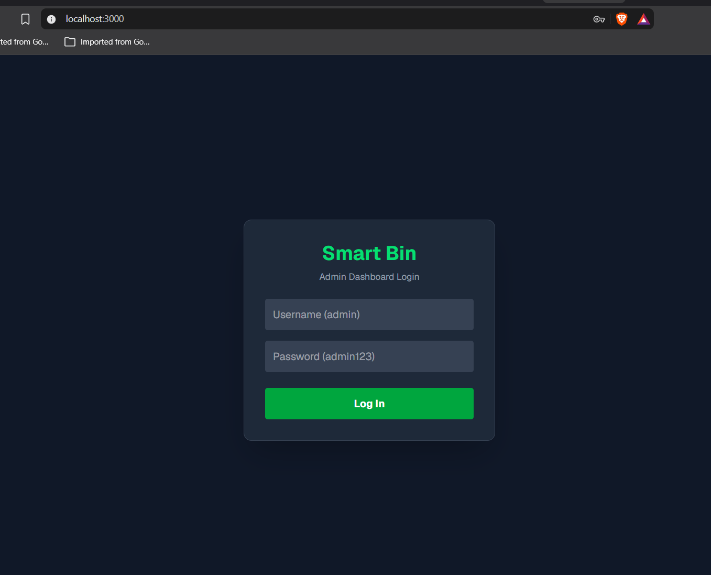

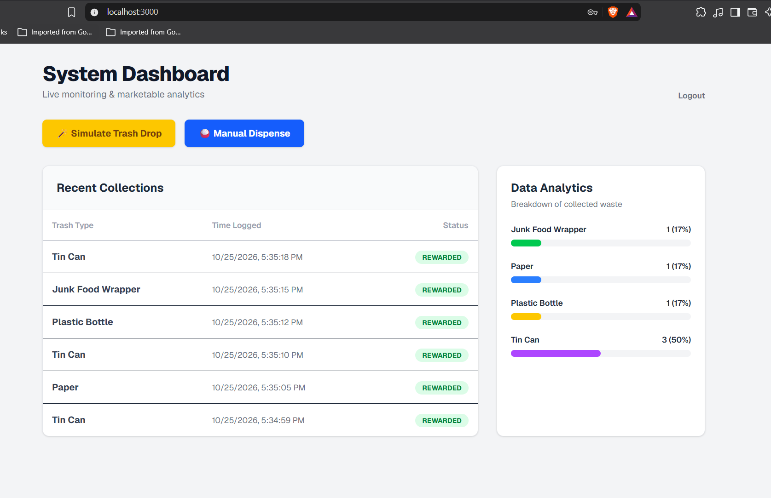

- Test Case 2: Backend Simulation (API)
  - Action: Click the "🪄 Simulate Trash Drop" button on the dashboard.
  - Expected Result: The backend terminal in VS Code logs a new TRASH_DETECTED event and confirms the data was saved to the database.
  - Result: [PASS]
  - Screenshot:
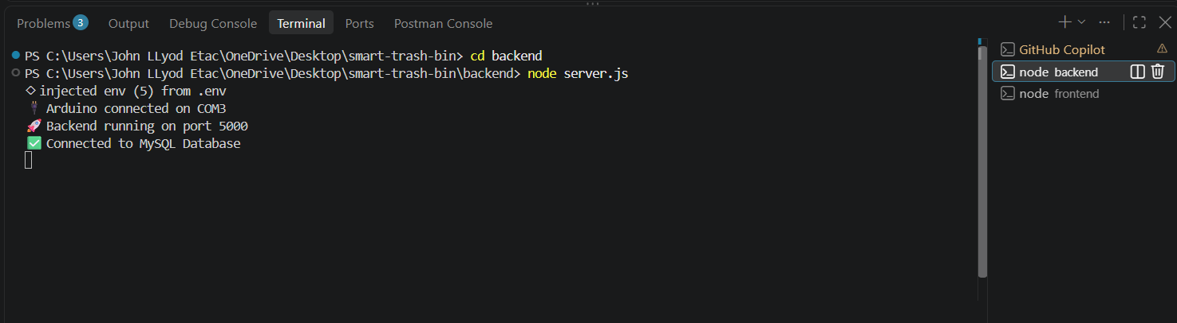

- Test Case 3: Database (CRUD)
  - Action: Open phpMyAdmin and check the trash_logs table.
  - Expected Result: The new record generated by the simulation button appears in the MySQL database with the correct timestamp.
  - Result: [PASS]
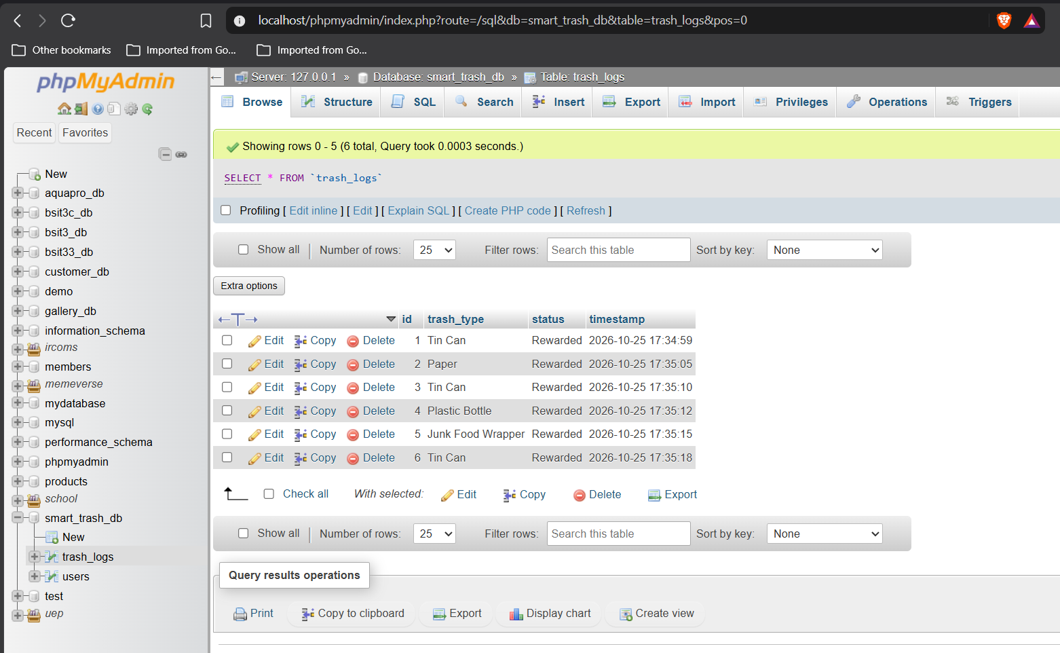
  - Screenshot

- Test Case 4: Hardware Integration (Sensor & Actuator)
  - Action: Wave hand in front of the HC-SR04 Ultrasonic Sensor.
  - Expected Result: The Arduino sends a signal to the backend, the servo motor rotates 90 degrees to dispense rice, and the web dashboard updates automatically.
  - Result: [PASS]
  - Screenshot: (Insert a photo of your physical Arduino setup with the serial monitor open)

